Experiment No. 2
Signal Operations and Transformations
OBJECTIVE:
  - To perform amplitude scaling and time scaling of continuous-time and discrete-time signals and analyze their effects on signal characteristics.
  - To perform time shifting and time reversal of continuous-time and discrete-time signals and analyze the resulting transformations.
  - To perform addition and multiplication of two discrete-time sequences and analyze the resulting signal characteristics.
  - To visualize and compare the original and transformed signals using MATLAB and interpret the effects of different signal operations.

To perform amplitude scaling and time scaling of continuous-time and discrete-time signals and analyze their effects on signal characteristics.

Experimental Procedure:
  - Generate the base signal x(t) = sin(2π5t).
  - Apply amplitude scaling using A = 2.
  - Apply time compression using x(2t).
  - Apply time expansion using x(t/2).
  - Plot the original and transformed signals using common axes.
  - Measure the amplitude and period of the transformed signals.
  - Compare the measured results with the theoretical scaling relationships.

MATLAB Coding:

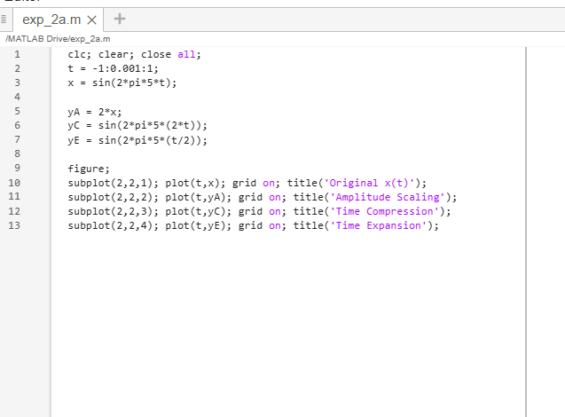
Results:
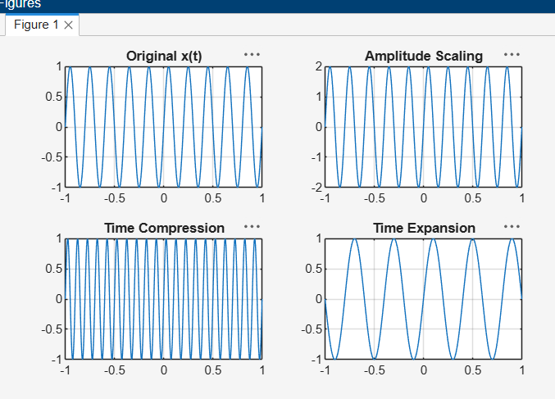

- To perform time shifting and time reversal of continuous-time and discrete-time signals and analyze the resulting transformations.

Experimental Procedure:
- Generate the base signal x(t).
- Create the delayed signal x(t−t₀).
- Create the time-reversed signal x(−t).
- Plot all signals using common axes.
- Measure or identify the time displacement.
- Compare the transformed waveforms with theoretical expectations.

MATLAB Coding:
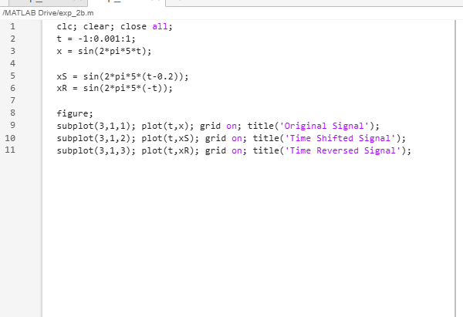
Results:
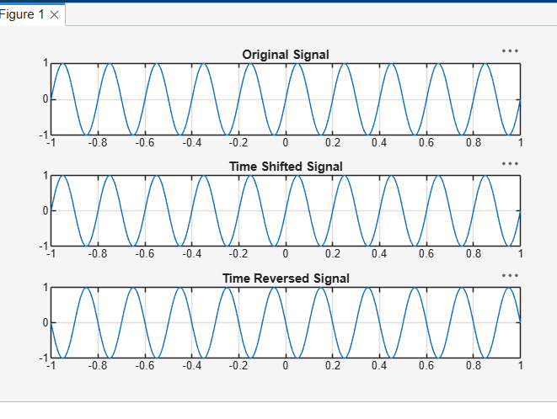
- To perform addition and multiplication of two discrete-time sequences and analyze the resulting signal characteristics

Experimental Procedure
- Define the sample index n.
- Enter x[n] and y[n] with aligned indices.
- Compute the sum sequence.
- Compute the product sequence using pointwise multiplication.
- Plot the input and resulting sequences using stem plots.
- Compare the calculated samples with manual/theoretical results.
MATLAB Coding:
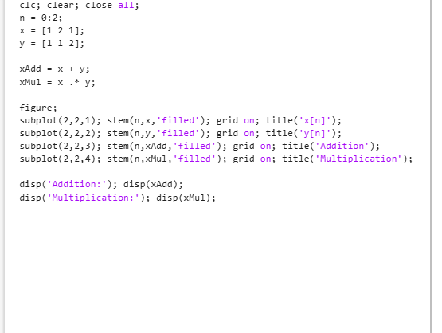

Results:
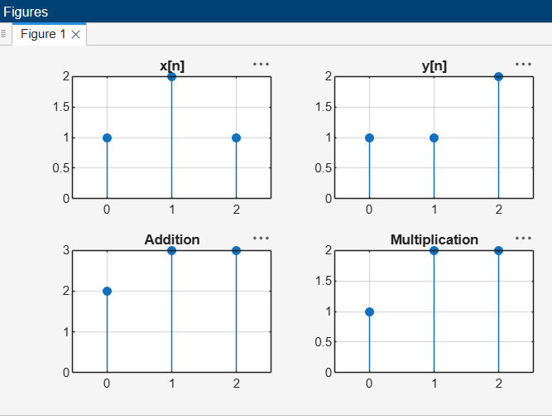

- To visualize and compare the original and transformed signals using MATLAB and interpret the effects of different signal operations.
Experimental Procedure:
  - Plot the original continuous-time signal.
  - Compare the amplitude-scaled, compressed and expanded signals with the original.
  - Compare the time-shifted and time-reversed signals using common axes.
  - Plot the two discrete-time input sequences and their sum and product.
  - Interpret the changes in amplitude, time scale, temporal position, orientation and sequence values.
  - Compare all simulation results with the theoretical signal-operation relationships.
MATLAB Coding:
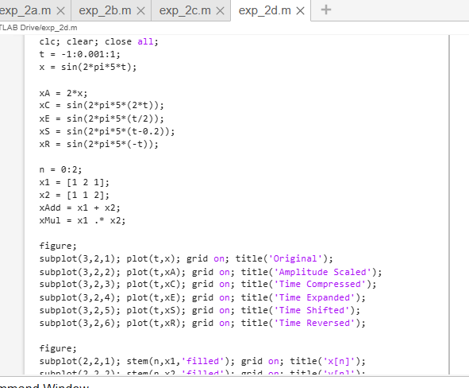
Results:
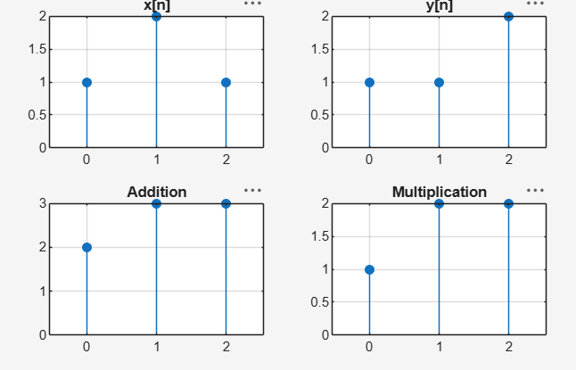
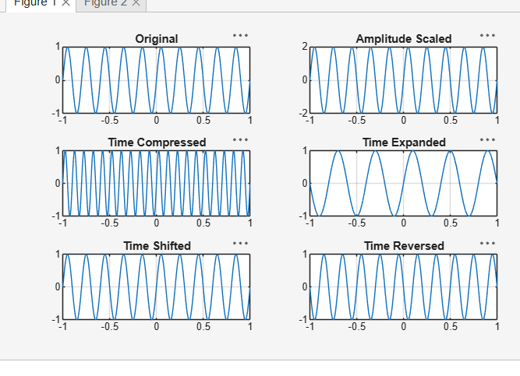

Conclusion:
Amplitude and time scaling, time shifting, time reversal, sequence addition and sequence multiplication were successfully implemented. The original and transformed signals were compared, and the observed waveform changes agreed with the corresponding theoretical signal-operation relationships.

